
UNIVERSITY OF ENGINEERING AND TECHONOLOGY, PESHAWAR
JALOZAI CAMPUS

COURSE TITLE
Introduction To AI Programming
CEP
SUBMITTED BY
Muhammad Saad
Reg no : 24JZELE0577
SUBMITTED TO
Sir Irasdullah
DEPARTMENT OF ELECTRICAL ENGINEERING
UNIVERSITY OF ENGINEERING AND TECHONOLOGY,
PESHAWAR, JALOZAI CAMPUS

This project uses the CityLearn 2022 dataset. You will work with building_2 and the price file to analyze energy consumption, PV generation, and cost. Load the building_2 CSV.
- Load the price CSV.
- Save the “Equipment Electric Power [kWh]” as the building’s electricity consumption in a list named non-shiftable load. Calculate the net sum, and it will be the building’s net consumption.
- In addition, store the “Solar Generation [W/kW]” in a list as PV generation per kW of the installed system. So, convert it to the generation units.
$$PV_{Gen}=\frac{4*Solar Generation [W/kW]}{1000}$$
After multiplication, store the solar generation in a list named Net solar generation of building 2.
- Save the price in a list and name it the price. Multiply the price by the unit consumed, hour by hour, and store the result in a list called “bill without PV”. Calculate its net sum and display it.
- Subtract the solar generation from the net electricity consumption. Now that you have both positive and negative entries. Save it in a list named Net consumption.
- Split net consumption into the positive entries in a new list called “Net electricity consumption with PV”. And another one with a negative value, which wasted energy, is in surplus and can be exported to the grid or stored in a battery for later use. Calculate the net sum of both net consumption and wasted energy.
- Visualize and interpret the data in a good-looking way.

CODE:
Task # 1

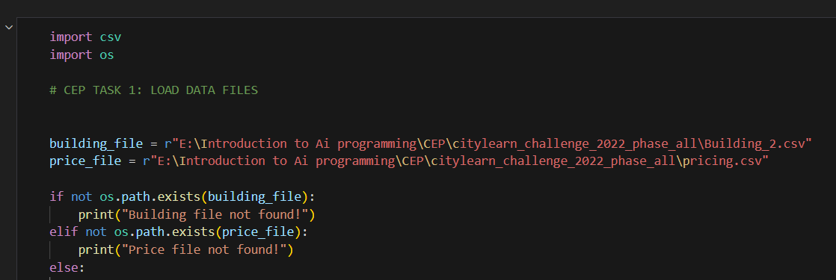

TASK # 2

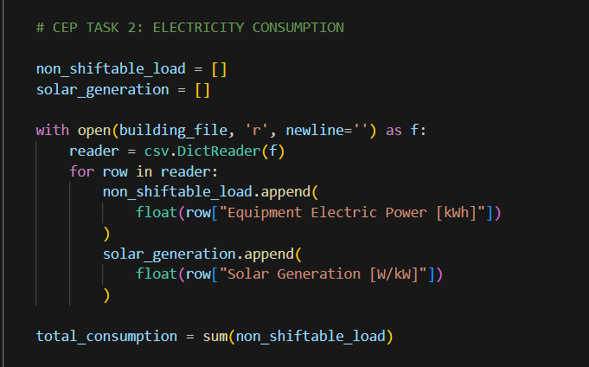

TASK # 3

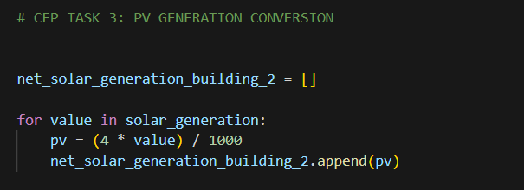

TASK # 4

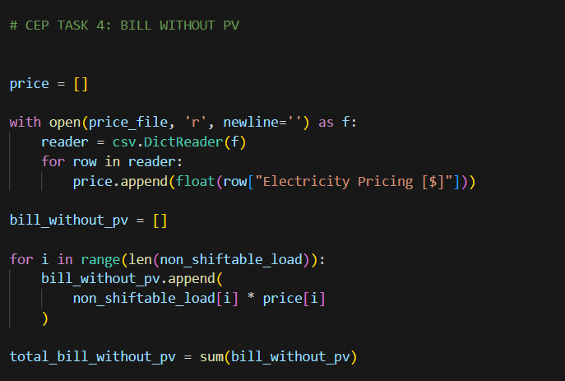

TASK # 5

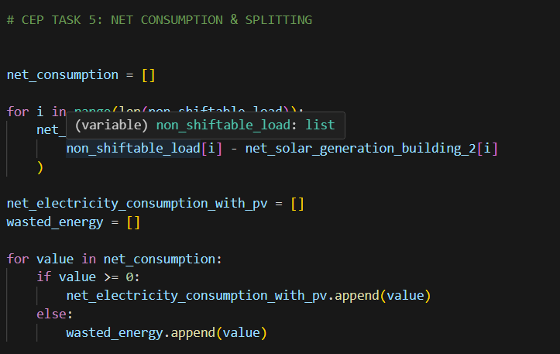

FINAL OUTPUT :
